WEEK 4 – ASSIGNMENT
Title: Azure Cloud Fundamentals and Data Pipeline Implementation using ADF
Objective: To understand Azure cloud concepts and build a complete data pipeline using Storage Account and Azure Data Factory.
Task 1: Screenshot of Resource Group
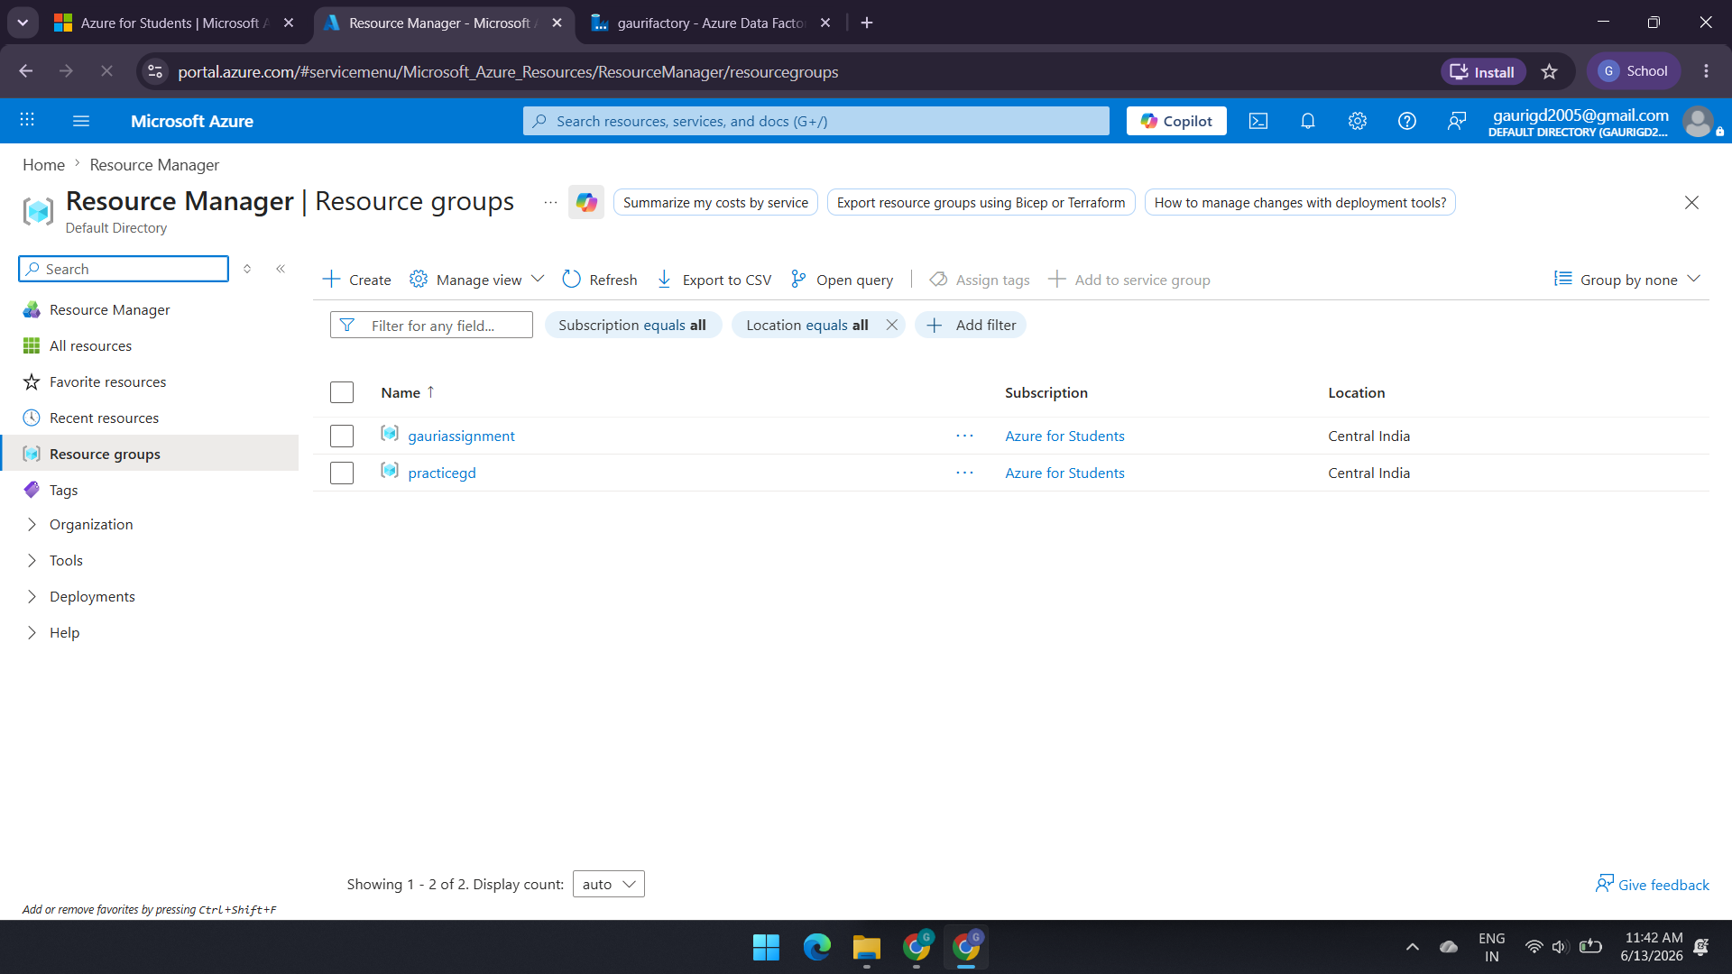TASK 2: Screenshot of container with uploaded file 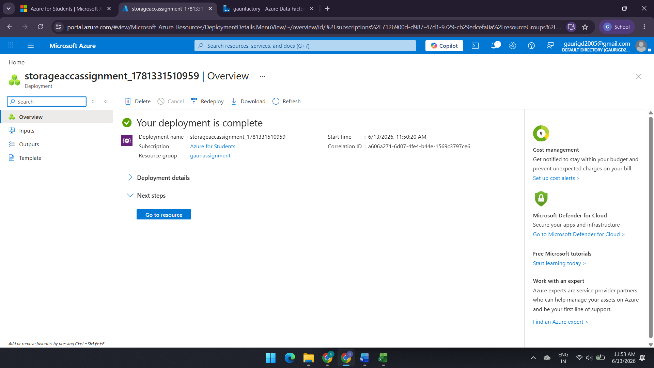
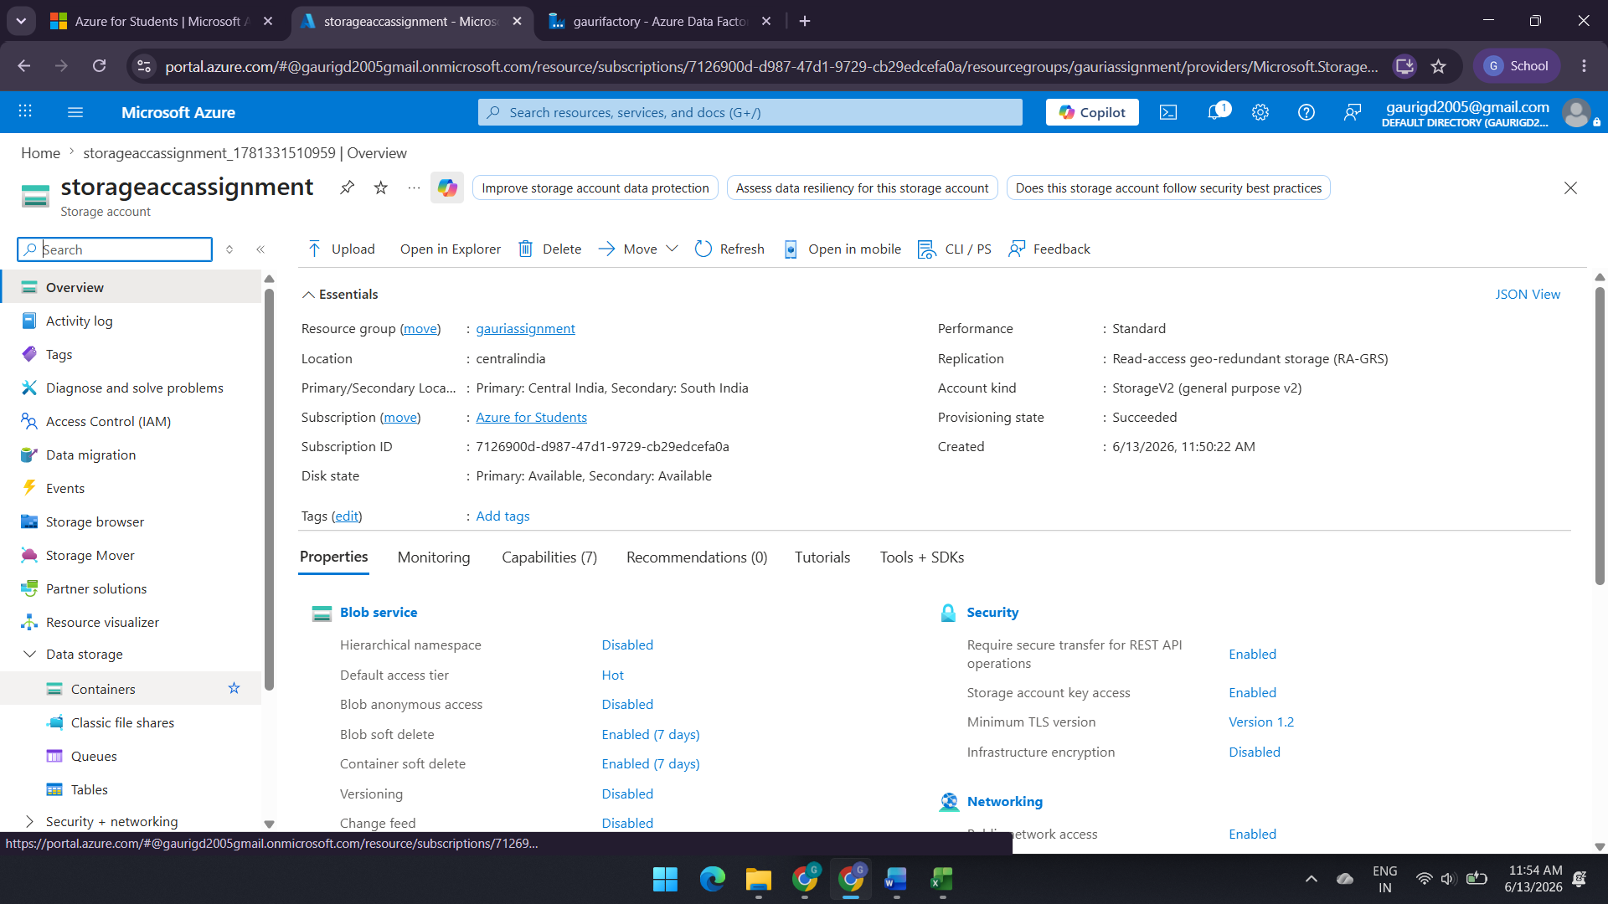
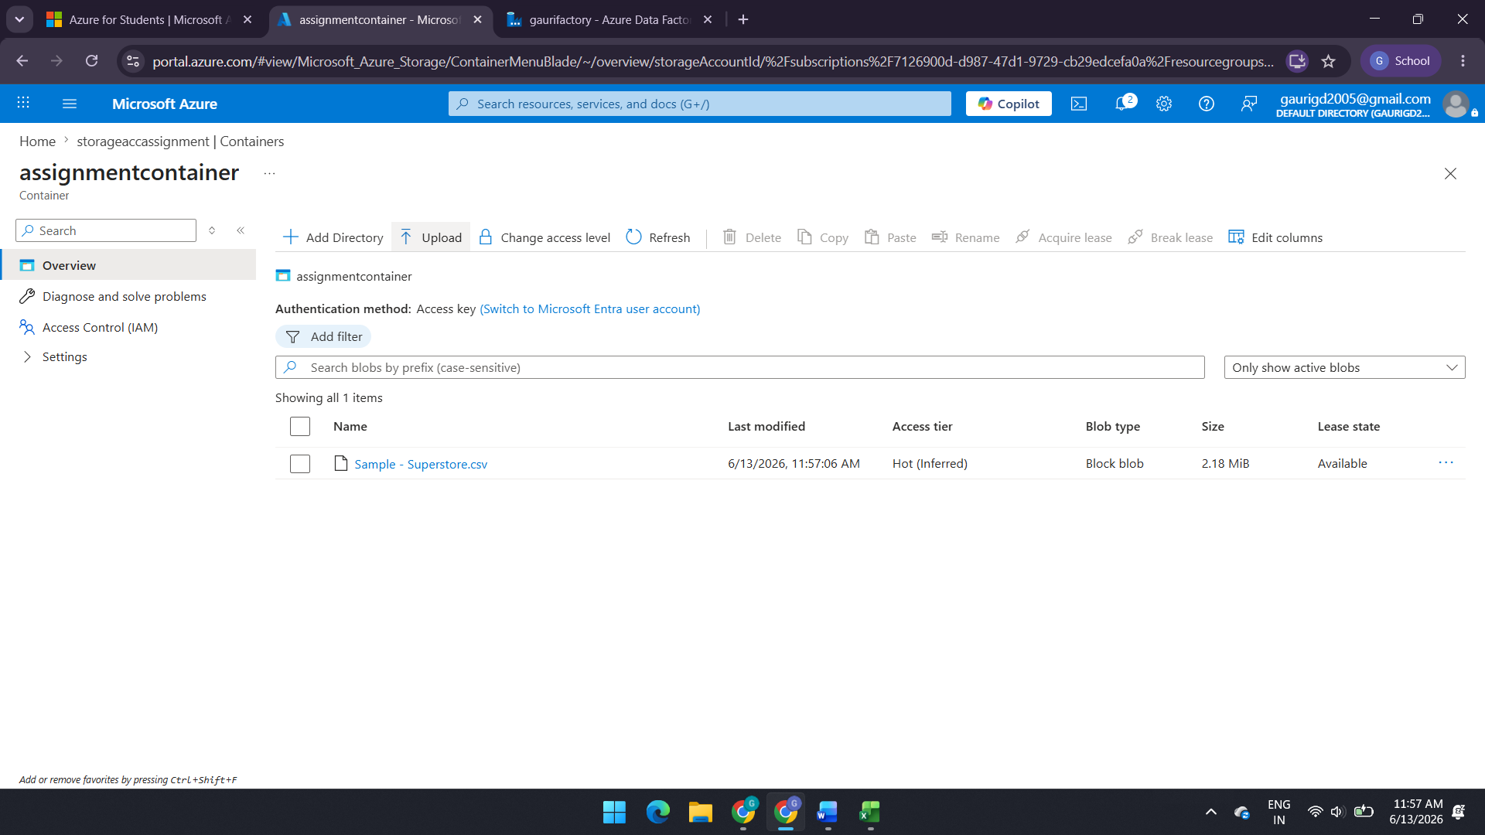

- Task 3: Screenshot of Linked Service
- Screenshot of dataset
- Screenshot of Get Metadata activity

1)Linked Services
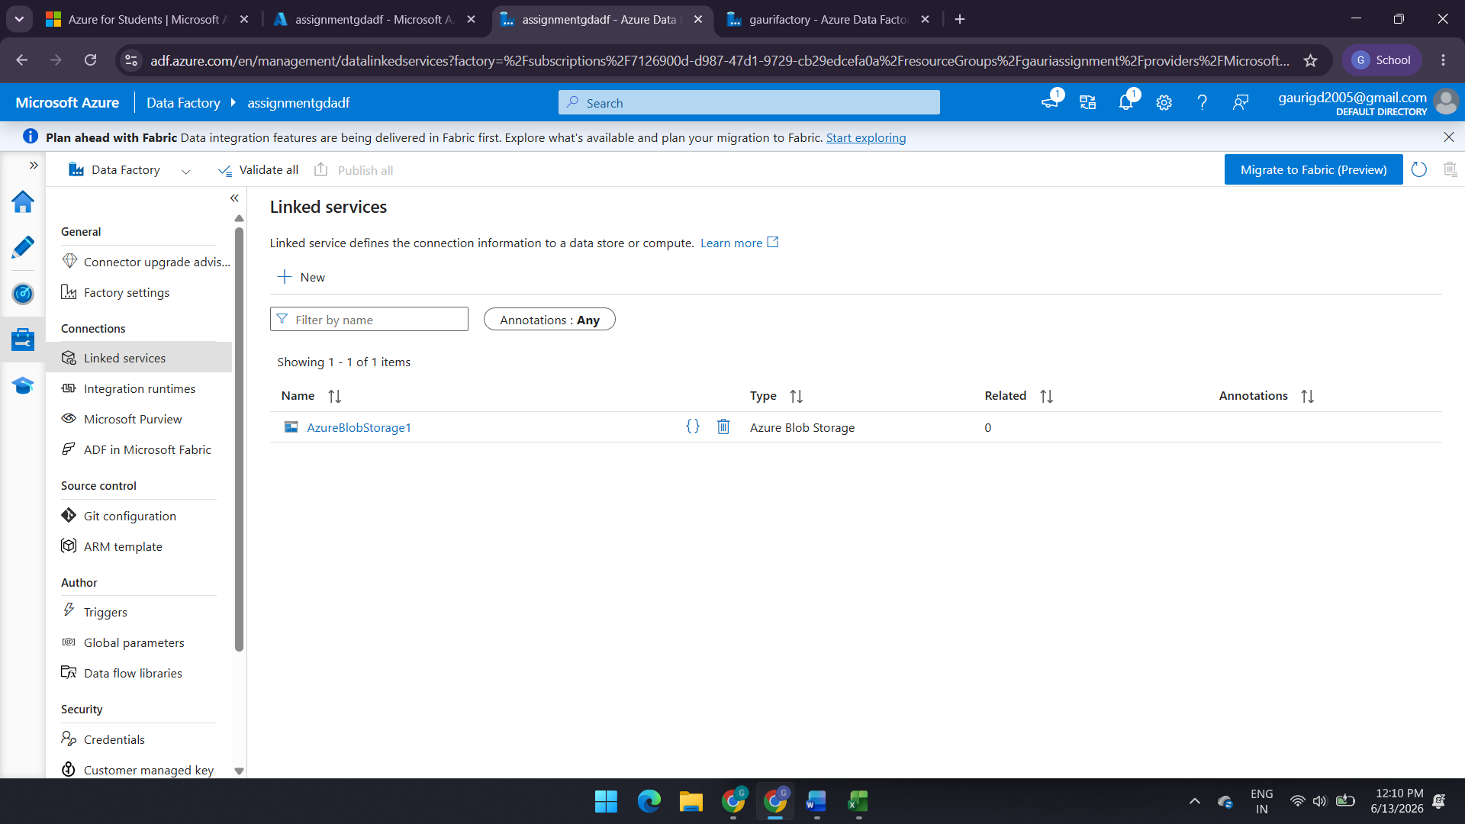
2)Dataset(Source and Destination):-
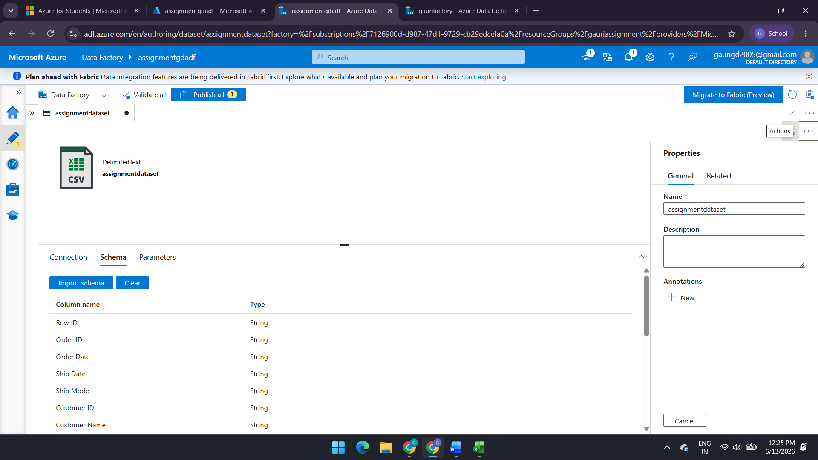
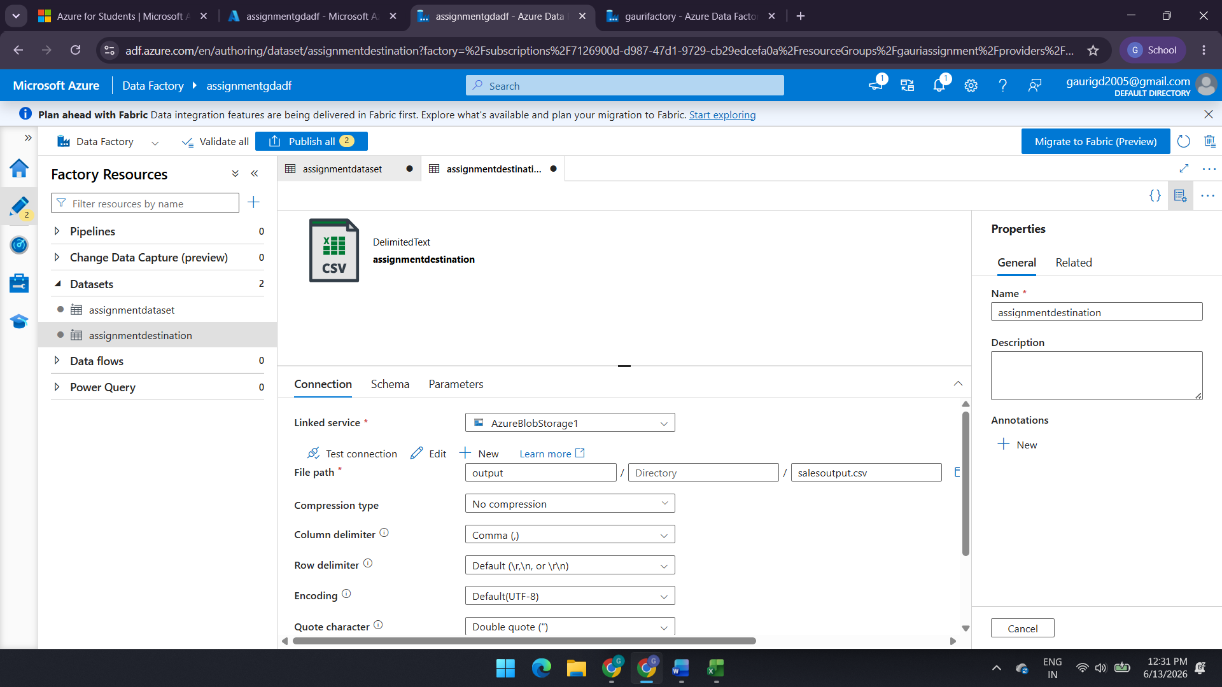
3) Get Metadata Activity(size & exists)
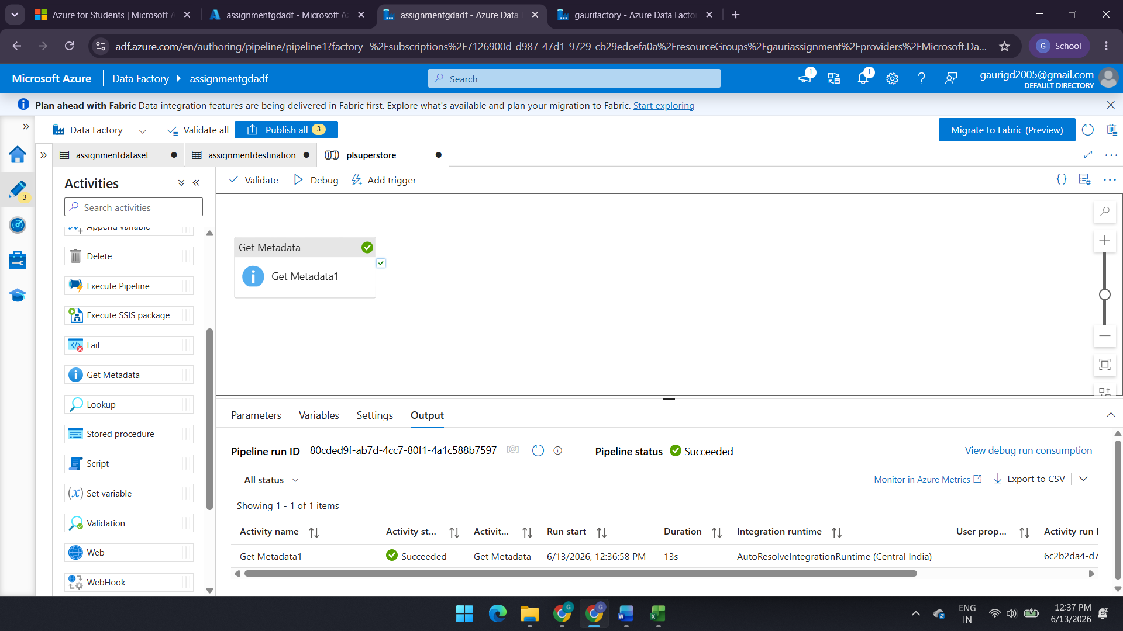
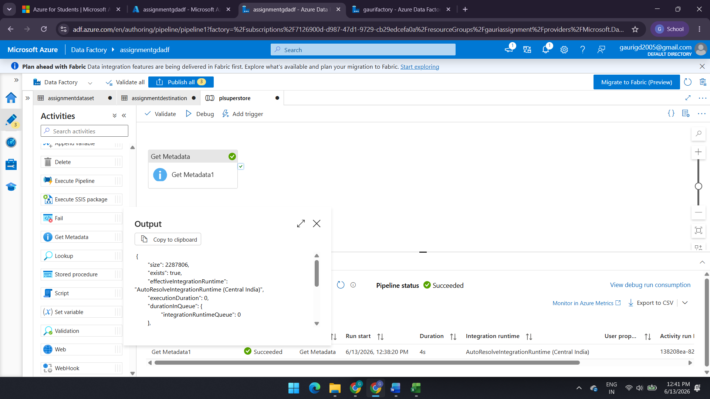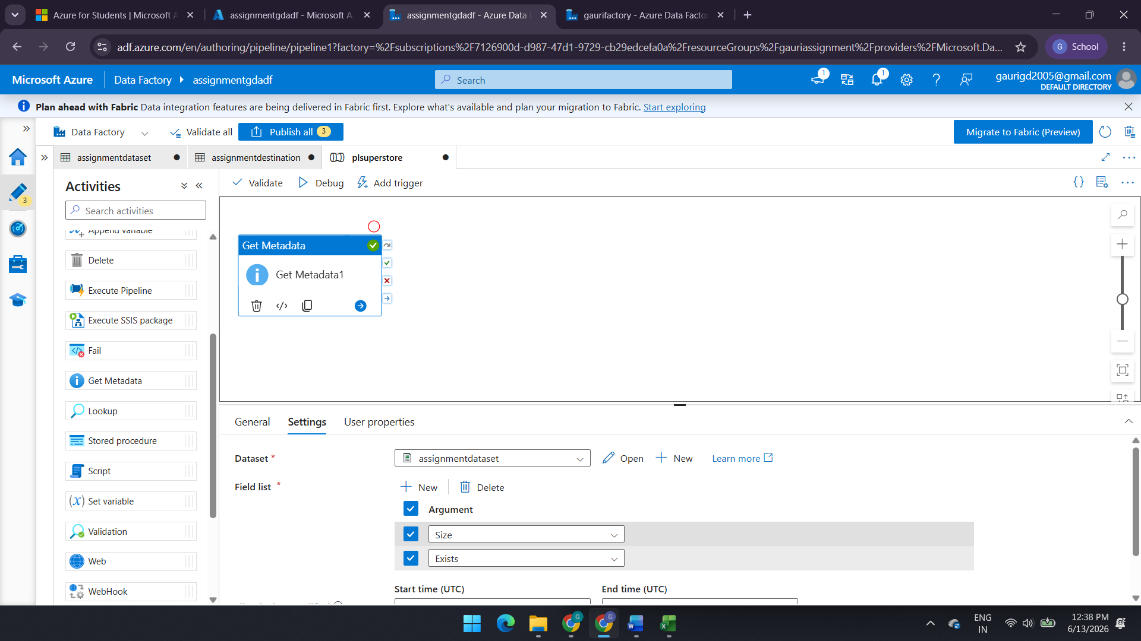

Task 4: Screenshot of pipeline design

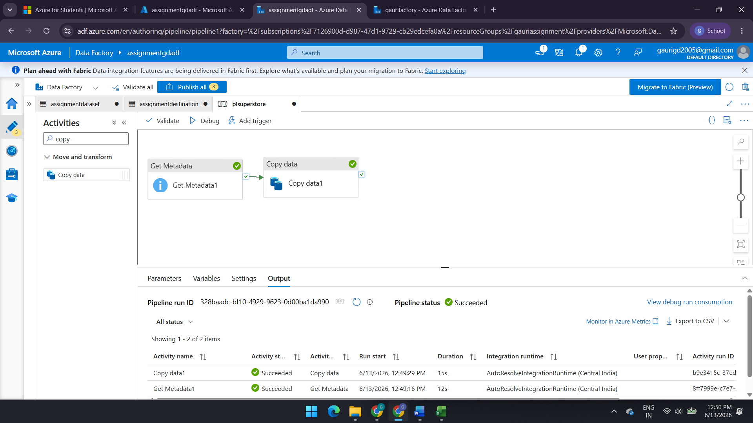
Task 5: Screenshot showing pipeline execution (Succeeded)
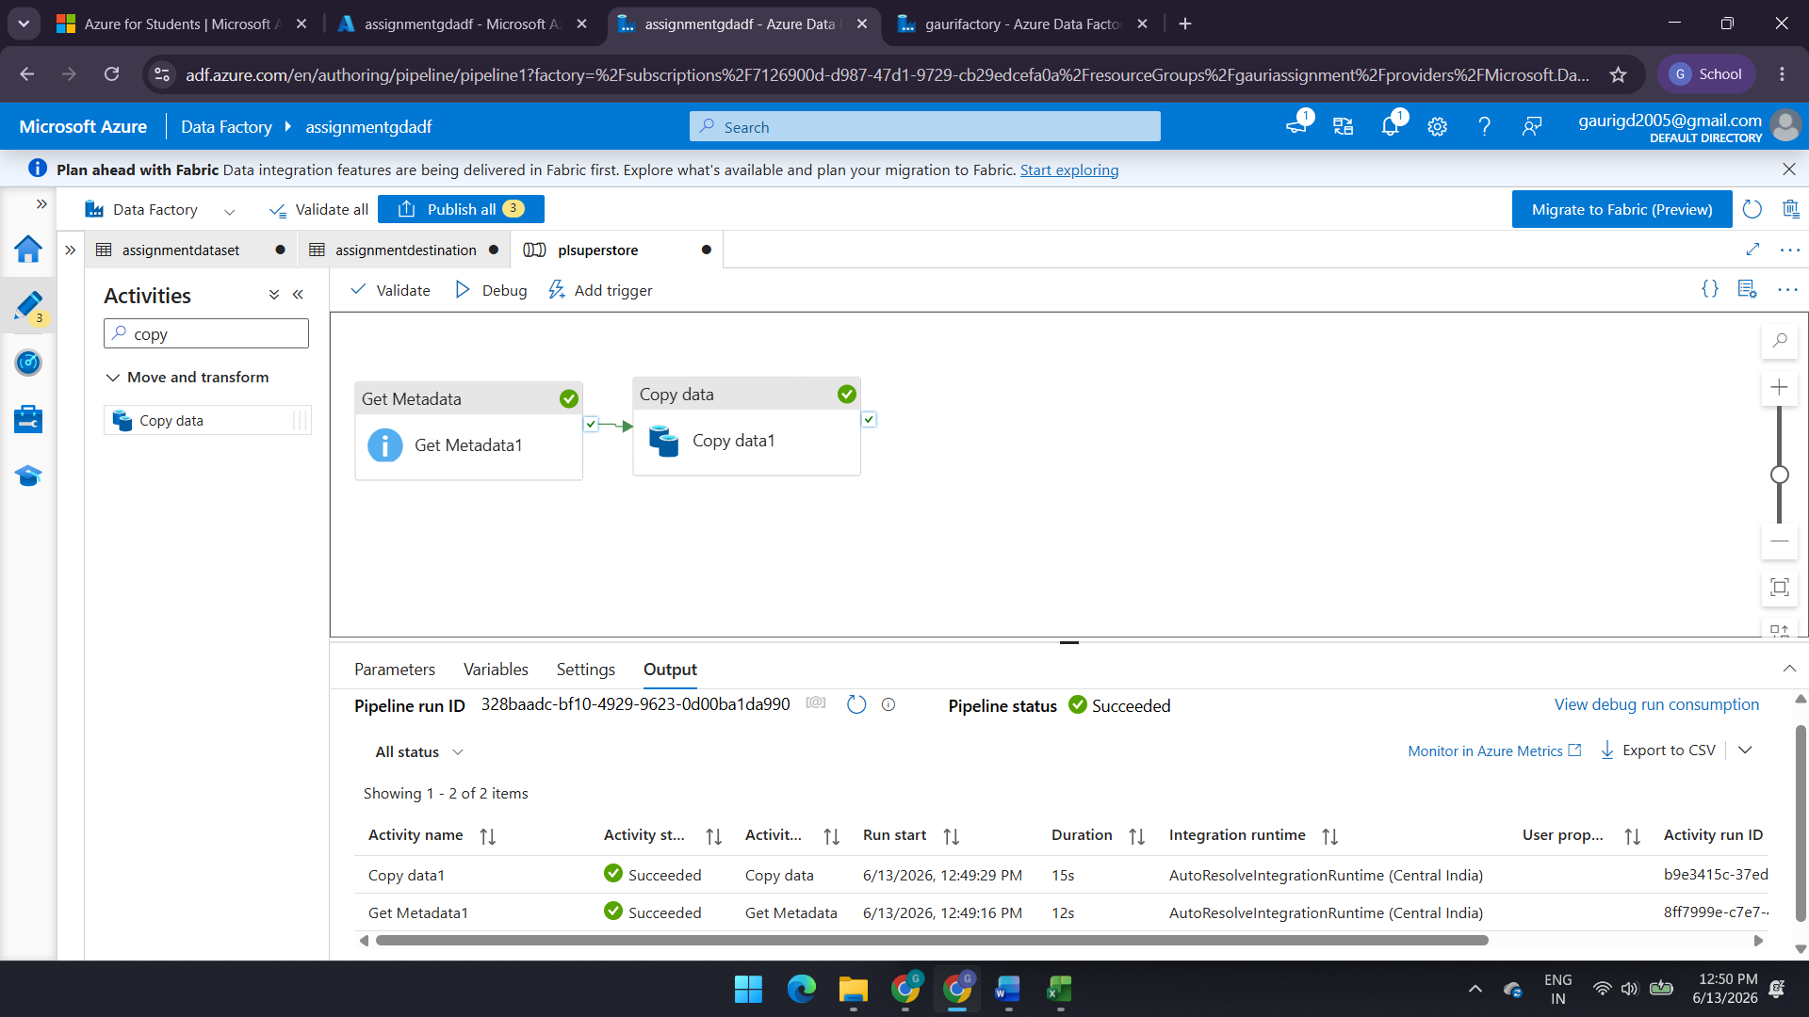

Task 6: Screenshot of role assignment
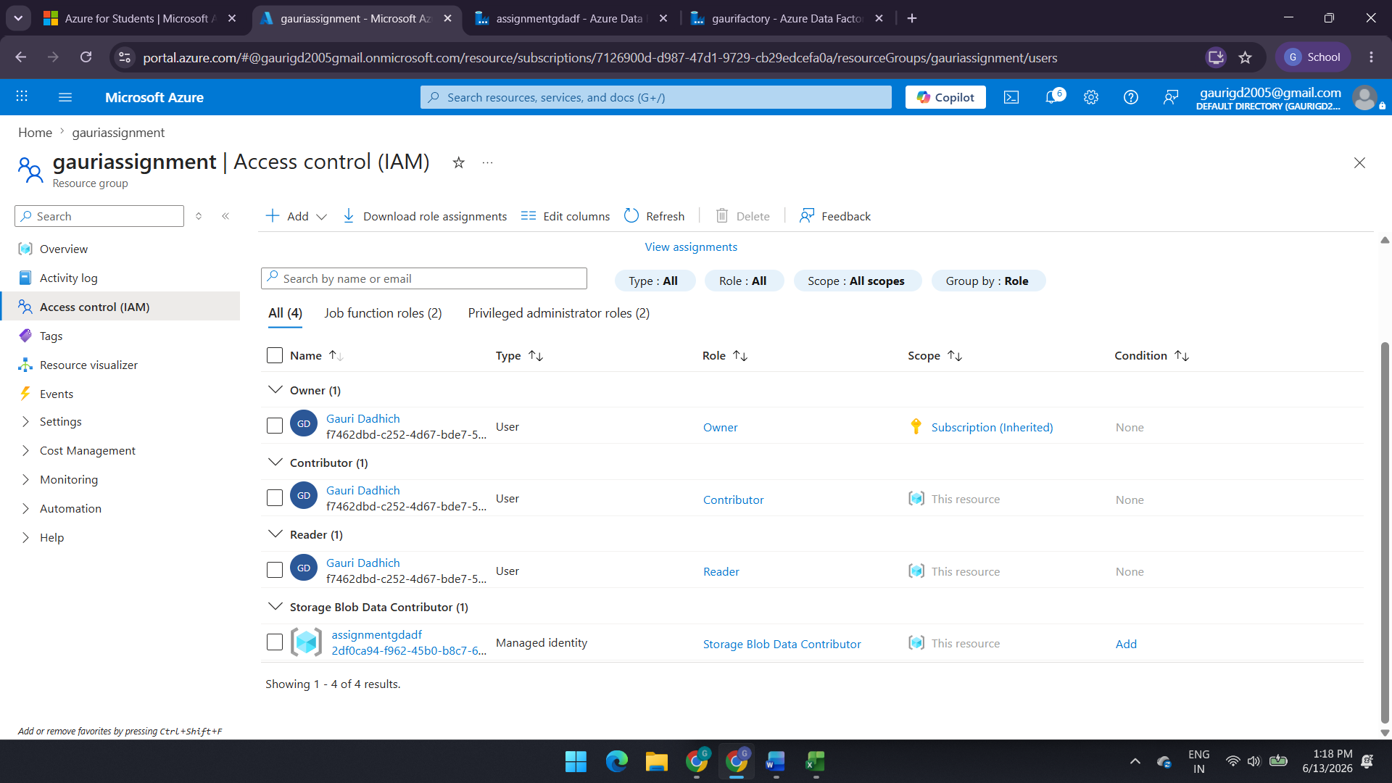

Copy Data Activity result:-
